[40%] Ping 測試 –2 圖

x1_PC3 -> 192.168.x2.1 (第 1區->第2區)

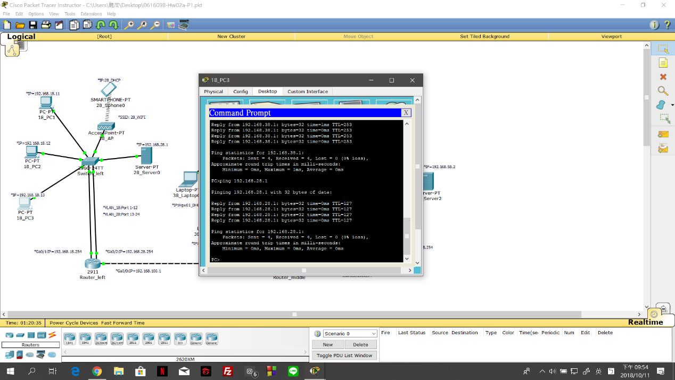

18_PC3(192.168.18.13) -> Switch_left ->透過VLAN_18到Router_left ->透過VLAN_28回到Switch_left ->28_Server0(192.168.28.1)

x3_Laptop_01 -> 192.168.x4.1 (第3區->第4區)

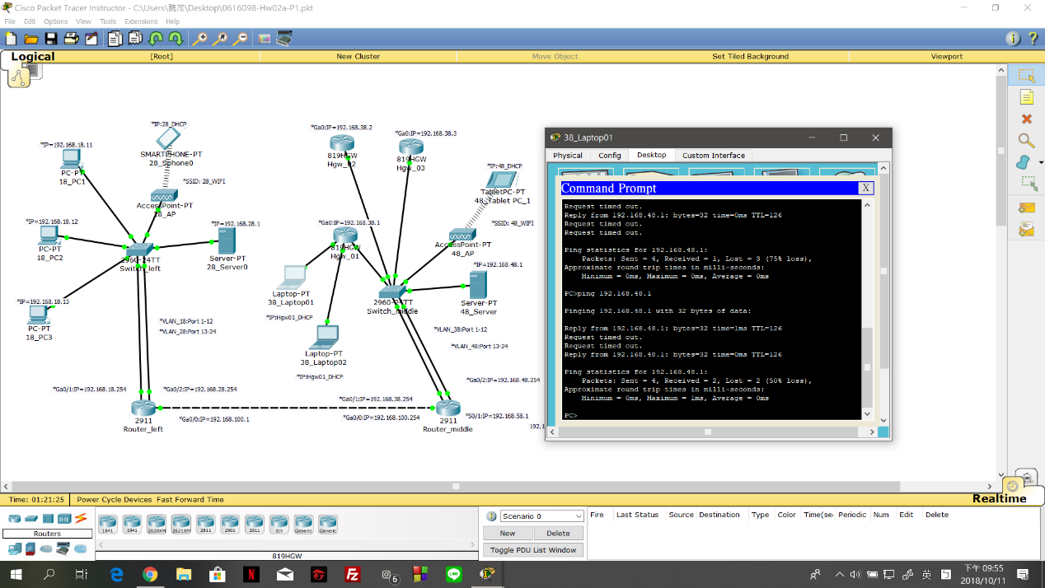

38_Laptop_01 (10.10.10.3(Hgw_01分配的))-> Hgw_01->Switch_middle->透過VLAN_38到Router_middle->透過VLAN_48到48_Server(192.168.48.1)

[60%] Tracert 測試 -3 圖

192.168.x2.1 -> x1_PC (第2區->第1區)

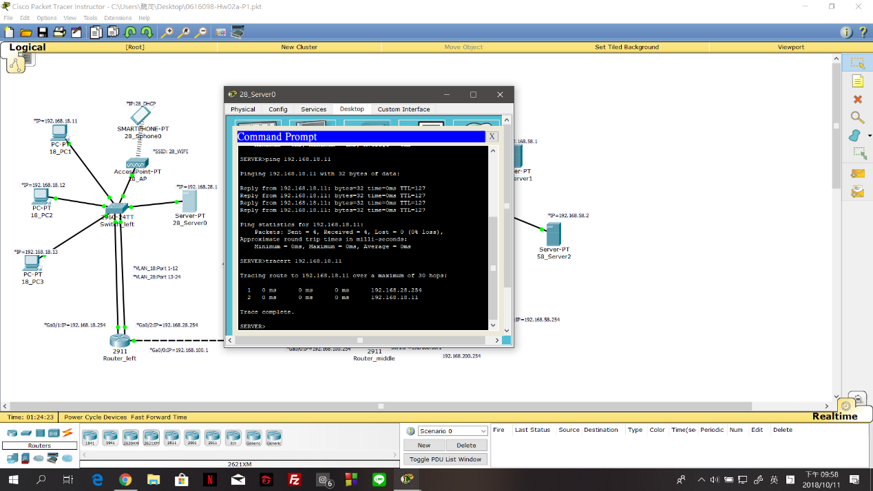

28_Server0(192.168.28.1) -> Switch_left -> 透過VLAN_28到Router_left -> 透過VLAN_18回到Switch_left -> 18_PC1(192.168.18.11)

x1_PC3 -> 192.168.x4.1 (第1區->第4區)

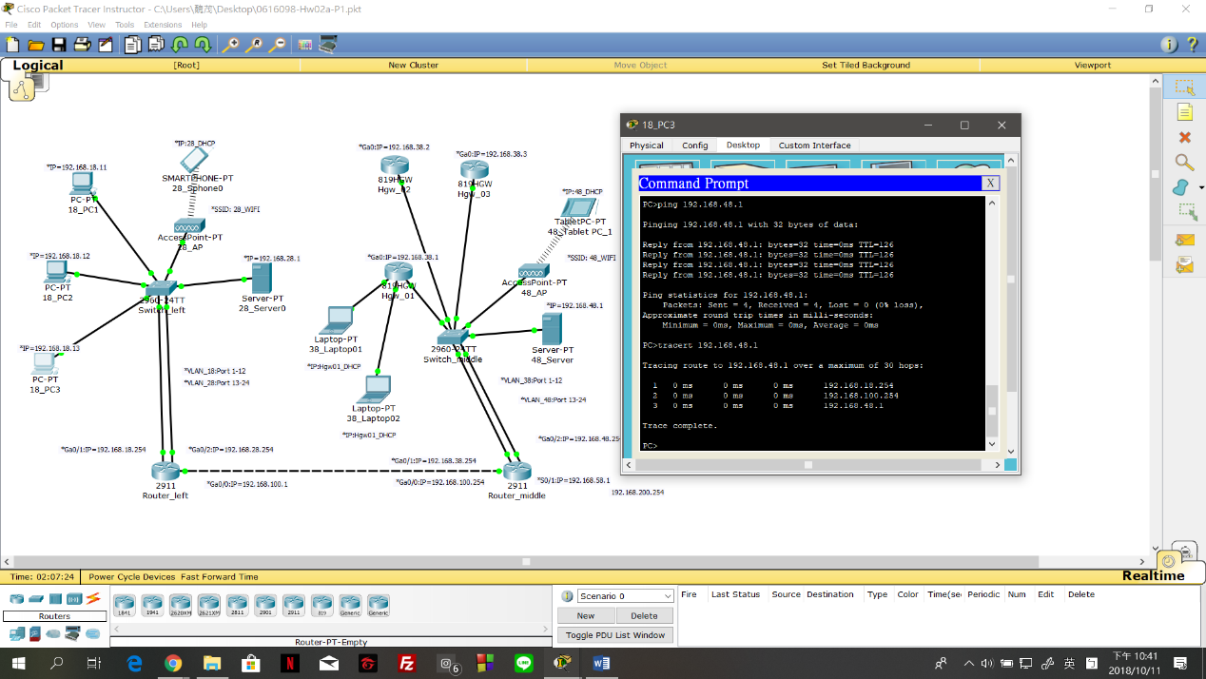

18_PC3(192.168.18.13) -> Switch_left -> 透過VLAN_18到Router_left -> Router_middle ->透過VLAN_48到Switch_middle -> 48_Server(192.168.48.1)

X4_Tablet PC_1 -> 192.168.x2.1(第4區->第2區)

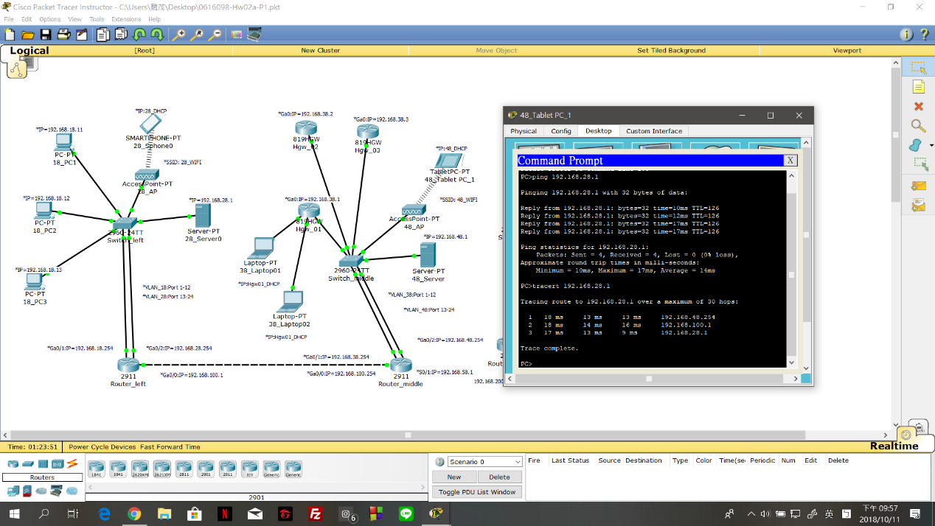

48_Tablet PC_1透過SSID: 48_WIFI配對到48_AP -> Switch_middle ->透過VLAN_48到Router_middle -> Router_left ->透過VLAN_28到Switch_left -> 28_Server0(192.168.28.1)